**CELTA Application and Pre-interview Task**

**Please complete this and email back to** [**stuart@ihtorquay.uk**](mailto:stuart@ihtorquay.uk)

**Name:**

**Course date:**

**Personal details**

Title:

First name:

Last name:

Please indicate your age:

|  |  |
| --- | --- |
| 18 - 25 |  |
| 26 - 35 |  |
| 35 - 50 |  |
| 50 + |  |

Nationality

Is there anything you would like to say about your identity (optional):

Email:

Phone number:

Mailing address:

|  |
| --- |
|  |

**Languages**

First language(s):

Other languages:

Please indicate level of proficiency in terms of speaking, reading, listening and writing for other languages:

**Please provide a brief summary of your qualifications from higher education, college or school? Provide subjects, grades and year (we will need to check qualifications at some stage).**

**If English is not your first language, please state your highest English language qualification with your score/grade and date of exam.**

**Experience**

Do you have any English Language Teaching experience?

Please give details and dates.

Do you have any other teaching experience?

Please give detail and dates.

What is your current or most recent job?

Is there something unusual or special about yourself that you would like to share (optional)?

How did you hear about the CELTA course at IH Torquay?

**Accommodation**

Will you need help with finding accommodation?

Do you have any medical condition or health problems (e.g. serious allergy, epilepsy, stress-related problems) or learning difficulties (e.g. dyslexia) that tutors should be aware of, and that may mean you require additional support during the course?

Yes / No

If yes, please provide some details below:

**Tasks:**

The purpose of these tasks is for you to outline your intentions and help us ascertain your knowledge of language systems. It is not a test.

The following reference will help you with the language tasks:

**Swan, M. Practical English Usage. OUP**

**1. Briefly outline** in a few sentences why you want to be a teacher of English as a foreign language to adults.

|  |
| --- |
|  |

**2. Grammar – tenses**

For this task, please identify the parts of speech which are underlined in the following text. Select from the following tenses in the box:

|  |
| --- |
| Simple past Present perfect  Present simple Present continuous  Present simple passive Past simple passive  Present perfect continuous Past perfect  Past continuous |

1. Had reached =

2. Tell =

3. Was chosen =

4. Have started =

5. Is stored =

6. Is also changing =

7. Has been building =

8. Visited =

9. Was pretending =

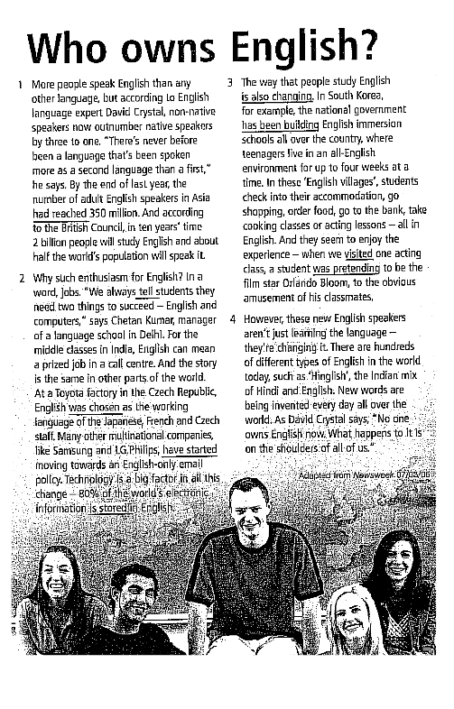

**Task 2 Learner errors - grammar**

The following sentences contain typical learner errors. Can you correct the error and explain **why** it is wrong?

**Example:**

Did you went to the cinema yesterday?

Correction: Did you go to the cinema yesterday?

Explanation: The learner has used the past simple form of ‘go’, but a past simple question in English is formed by ‘did + the base form’. (This use of an auxiliary ‘did’ in questions is not usual in many languages).

1. Could you provide me with some informations about the CELTA course.
2. Will you can help me to move these boxes, please?
3. Carlos tidies his bedroom at the moment.
4. Sorry, I won’t be able to come shopping with you this afternoon because I’ll go to the dentist.
5. An African elephant is more bigger than an Indian elephant.
6. When I was in Spain 2 years ago, I’ve been to Madrid.

**Task 3 Learner errors – vocabulary**

The following sentences also contain typical learner errors. Can you correct the error and explain **why** it is wrong?

1. My friend said me that he was going to meet me at the bus stop.
2. Whenever the students are late, the teacher is slightly furious.
3. Is it OK if I use your phone to do a call?
4. I live in an antique house – it’s more than 200 years old!

**Task 4. Pronunciation**

Say the following words aloud to yourself and think about what problems learners may have with pronouncing them. Consider **sounds** and where the **main stress** lies in each word. Follow the example and identify issues.

Example:

* **theatre**

a learner might struggle with the ‘th’ sound in ‘theatre’ or might want to put the stress on the second syllable instead of the first.

* **comfortable**
* **worked**
* **permit**
* **answer**
* **relationship**
* **engineer**

Please confirm that all the information provided is accurate to the best of your knowledge?

Date:

Signature: